SDLC (software Development Life Cycle)

The Software Development Life Cycle (SDLC) is a structured process used by software teams to plan, design, develop, test, deploy, and maintain software systems. It ensures the delivery of high-quality software within a defined timeline and budget.
Without a structured SDLC, software development becomes chaotic. Teams may miss requirements, blow budgets, or deliver buggy code that doesn't solve the user's problem. SDLC provides:
- Visibility: Stakeholders know exactly what is happening at every stage.
- Quality Control: Testing is integrated into the process, not an afterthought.
- Risk Management: Potential pitfalls are identified during the planning phase.
- Cost Estimation: Helps in predicting timelines and budgets accurately.

STAGES OF SDLC
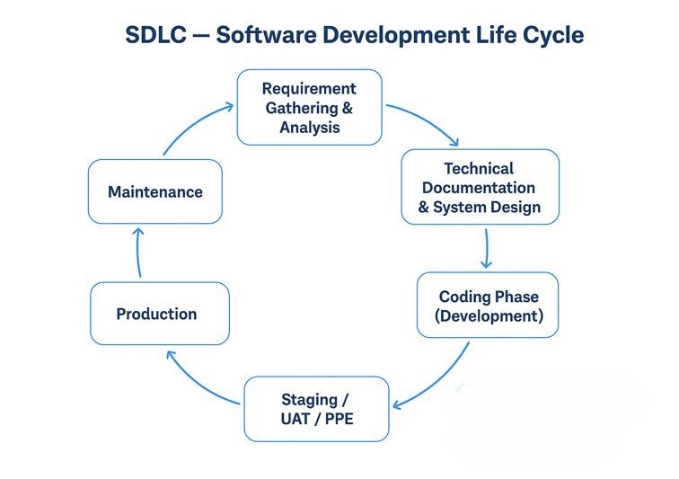

- Requirement Gathering & Analysis
The SDLC begins with Requirement Gathering and Analysis, where the Product Owner or client explains the complete needs of the project. This includes business goals, feature requirements, wireframes, and any special rules or constraints. The development team analyses these details to fully understand what must be built, what problems the software should solve, and what is out of scope. The output of this stage is a formal requirement document (SRS/BRD), which is reviewed and approved before moving ahead.

- Technical Documentation & System Design
After the requirements are finalized, the Tech Lead and Architect create the Technical Document. This document includes decisions about the system architecture, such as how many classes, modules, components, interfaces, and inheritance structures will be used. Database design, APIs, security aspects, and performance considerations are also planned here. The technical design undergoes multiple reviews to ensure it is scalable, maintainable, and efficient. This stage produces the technical blueprint of the entire project.

- Coding Phase (Development)
Once the technical design is approved, the Coding Phase begins. Senior Software Engineers (SSEs) and Software Engineers (SEs) write the actual code according to the design documents. They develop backend and frontend modules, use version control systems like Git, and follow coding standards. Developers perform unit testing to ensure their individual components work correctly. The end result of this phase is a fully coded application that is ready to be tested by the QA team.

- Testing Phase (QA Testing)
After coding is complete, the application is moved to the QA (Quality Assurance) server for detailed testing. QA engineers execute functional, integration, regression, and UI tests to verify that the application behaves as expected. They log any bugs or issues they find using tracking tools such as JIRA or Azure DevOps. Developers fix the bugs, and QA retests them until the software reaches a stable and acceptable quality level. Only after passing thorough testing does the product move to the next stage.

- Staging / UAT / PPE (Pre-Production Cycle)
The next combined phase is Staging, UAT, and PPE. In the Staging environment, the system undergoes regression testing, load testing, and automation testing to ensure overall stability. After this, the build is shared with the Product Owner or client for UAT (User Acceptance Testing), where they confirm that the application fulfils business requirements in real-life scenarios. Once approved, the application is deployed to the PPE (Pre-Production Environment), which is a mirror of the production setup. This stage is used for final validation, configuration checks, and deployment rehearsals before going live.

- Production (Go Live)
After successful validation in PPE, the application is deployed to the Production Environment. This is the live environment where real users interact with the software. The development and DevOps teams closely monitor the system for performance, errors, stability, and user activities. Any critical issues are quickly resolved to ensure a smooth user experience. This stage marks the official launch of the product.

- Maintenance
Once the software is live, it enters the Maintenance phase. The development team continues to support the system by fixing bugs reported by users, optimizing performance, and implementing small improvements or enhancements. Regular updates, security patches, and monitoring ensure that the application stays reliable and performs well over time. This phase continues throughout the product’s life cycle.

8. Continuous Loop Back to Requirements
SDLC is a continuous, never-ending loop. After Maintenance, the cycle naturally returns to the Requirement Gathering phase again. This happens because the client often needs new features, improvements, or changes based on customer feedback and evolving business needs. As user expectations change and technology advances, new requirements are collected, and the SDLC cycle restarts—ensuring the product stays updated, competitive, and valuable.

